ICD-10 Follow On Class 1 Software Remediation Project

Event Capture
Graphical User Interface
Application Version 2.0

Release Notes
EC*2.0*114


July 2014

Department of Veterans Affairs
Office of Information and Technology
Product Development

Table of Contents

1. Introduction 1
1.1. Purpose 1
1.2. Background 1
1.3. Scope of Changes 2
1.4. Documentation 2
2. Primary and Secondary Diagnosis Search 3
2.1. Diagnosis Search and Display 3
2.2. Spreadsheet and Diagnosis Codes 4
3. Updated Screens 5
3.1. ICD Diagnosis Code Display 5
3.2. Enter/Edit Patient Procedures Summary 6
3.3. View Patients for this Procedure 7
3.4. View Selected Patients 8
3.5. PCE Data Summary Report 9
4. Technical Information 10
4.1. Routines 10
4.2. Online Help for ICD-10 Codes 10

(This page included for two-sided copying.)

Introduction

Purpose
The purpose of these Release Notes is to identify enhancements to the Event Capture (EC) package contained in patch EC*2*114.

Background
On January 16, 2009, the Centers for Medicare & Medicaid Services (CMS) released a final rule for replacing the 30-year-old International Classification of Diseases, Ninth Revision, Clinical Modification (ICD-9-CM) code set with International Classification of Diseases, Tenth Revision, Clinical Modification (ICD-10-CM) and International Classification of Diseases, Tenth Revision, Procedure Coding System (ICD-10-PCS) with dates of service or dates of discharge for inpatients that occur on or after the ICD-10 Activation Date.
The classification system consists of more than 68,000 codes, compared to approximately 13,000 ICD-9-CM codes. The system also expands the number of characters allotted from five to seven alphanumeric characters. This value does not include the decimal point, which follows the third character for the ICD-10-CM code set.
The ICD-10-CM code set has the potential to reveal more about quality of care, so that data can be used in a more meaningful way to better understand complications, better design clinically robust algorithms, and better track the outcomes of care. ICD-10-CM also incorporates greater specificity and clinical detail to provide information for clinical decision-making and outcomes research.
Note: The Event Capture Graphical User Interface (GUI) does not use ICD-10-PCS procedure codes.
ICD-9-CM and ICD-10-CM Comparison
ICD-9-CM | ICD-10-CM
13,000 codes (approximately) | 68,000 codes (approximately)
3-5 characters | 3-7 characters (not including the decimal)
Character 1 is numeric or alpha (E or V) | Character 1 is alpha; character 2 is numeric
Characters 2 - 5 are numeric | Characters 3–7 are alpha or numeric (alpha characters are not case sensitive)
Decimal after first 3 characters | Same

Scope of Changes
NOTE: Existing ICD-9 functionality has not changed.
Patch EC*2*114 makes the following changes to the Event Capture GUI application:
- Allows for entry, display, search (lookup), print, and storage of the ICD-10-CM diagnosis code set.
- Provides ability to search and display up to 100 ICD-10 diagnoses at a time.
- Replaces ICD-9-CM with ICD-10-CM as the diagnostic coding system for Event Capture procedures with a procedure date on or after the ICD-10 Activation Date
- Accommodates the period of time when the Event Capture GUI requires the use of dual code sets (ICD-9-CM and ICD-10-CM) for outpatient dates of service and inpatient discharge dates prior to and following the ICD-10 Activation Date as well as for reporting and research purposes.

Documentation
The Event Capture manuals are posted on the VistA Documentation Library (VDL) http://www.va.gov/vdl/application.asp?appid=39 page.
The following Event Capture user manuals are updated with changes for EC*2*114:
- Installation Guide
- Technical Manual
- User Manual
The following manual does not exist for this package:
- Security Guide
NOTE: Security Information is contained within the Event Capture GUI Technical Manual.

Primary and Secondary Diagnosis Search
NOTE: Existing ICD-9 functionality has not changed.
The Event Capture GUI determines which ICD code set version to use based on the associated dates for the event and the ICD-10 Activation Date. The “Date of Interest” is equivalent to the procedure date in the Event Capture package.
Note: Specifically, the DATE/TIME OF PROCEDURE field (#2) of the EVENT CAPTURE PATIENT file (#721) drives which of the ICD diagnosis code sets is added and stored for each procedure.
As part of EC*2*114, there is no change to the partial or full code search functionality for the ICD diagnosis search/lookup in Event Capture.

Diagnosis Search and Display
The Event Capture main menu bar Function tab options Data Entry and Spreadsheet allow ICD-10 diagnosis codes to be added and stored.
The Data Entry Menu of the Event Capture main menu bar Function tab allows the user to update the procedures with a primary ICD diagnosis and from zero to four secondary diagnoses through these options:
    - Data Entry by Patient – Enter/Edit Patient Procedure(s)
    - Data Entry by Procedure – Batch (Same Procedure, Multiple Patients)
    - Multiple Dates/Procs – Multiple Dates/Multiple Procedures
Example of Previous ICD Code Display
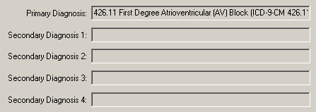

Example of Updated Search Result after the ICD-10 Activation Date
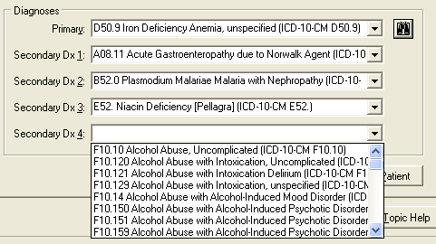

Spreadsheet and Diagnosis Codes
The Event Capture GUI now validates ICD-9 and 1CD-10 codes based on the date of the event and the ICD-10 Activation Date.
There are no changes to the spreadsheet feature in Event Capture GUI. The spreadsheet column, Diag Code, remains unchanged.
Spreadsheet Diag Codes Column
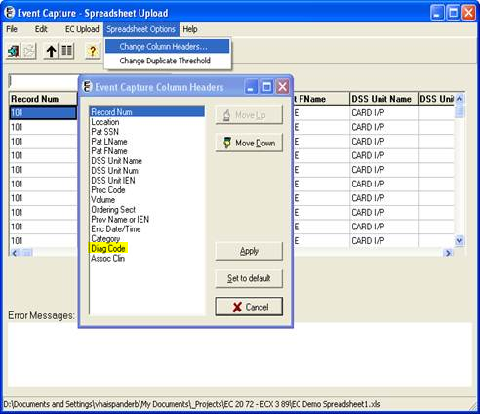

Updated Screens

ICD Diagnosis Code Display
The View Patient Record Details screen displays the primary ICD diagnosis and zero to four secondary diagnoses when the user chooses View Details from the View Selected Patients tab.
View Patient Record Details
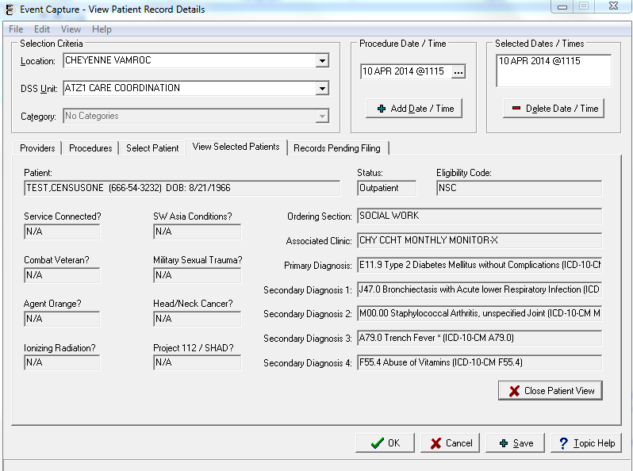

Enter/Edit Patient Procedures Summary
The Patient Summary screen displays ICD primary diagnoses for a single patient before and after patient procedures have been revised.
Enter/Edit Patient Procedures Summary
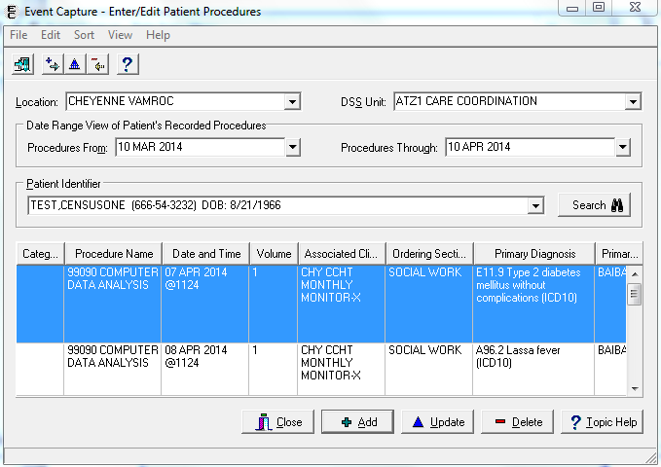

View Patients for this Procedure
The View Patients screen displays the primary ICD diagnosis when single procedures are updated for multiple patients.
View Patients for this Procedure
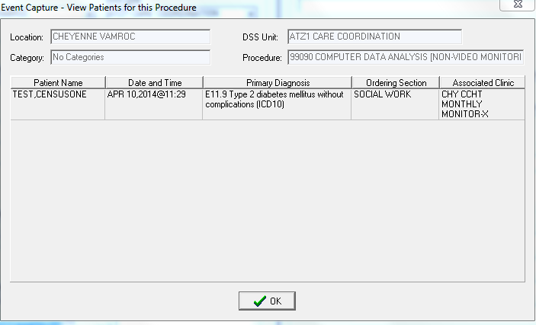

View Selected Patients
The View Selected Patients screen displays primary ICD diagnoses when multiple procedures are updated for multiple patients for multiple dates.
View Selected Patients
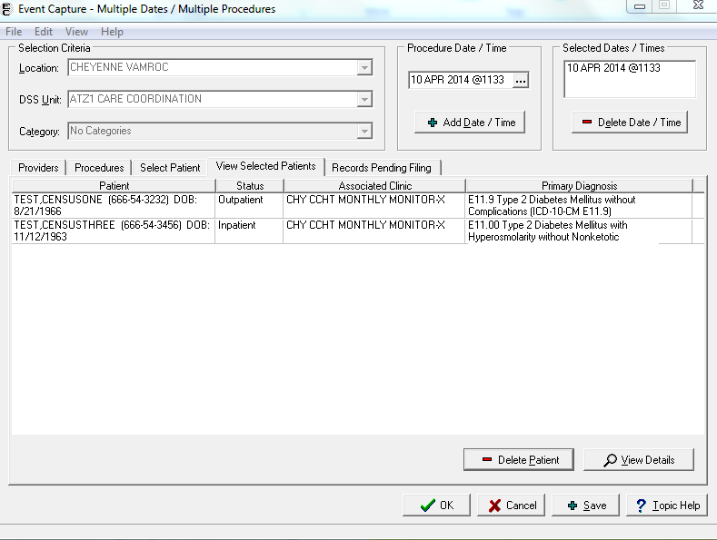

PCE Data Summary Report
The PCE Data Summary Report prints the primary ICD diagnosis code and from zero up to four secondary ICD diagnosis codes.
PCE Data Summary Report
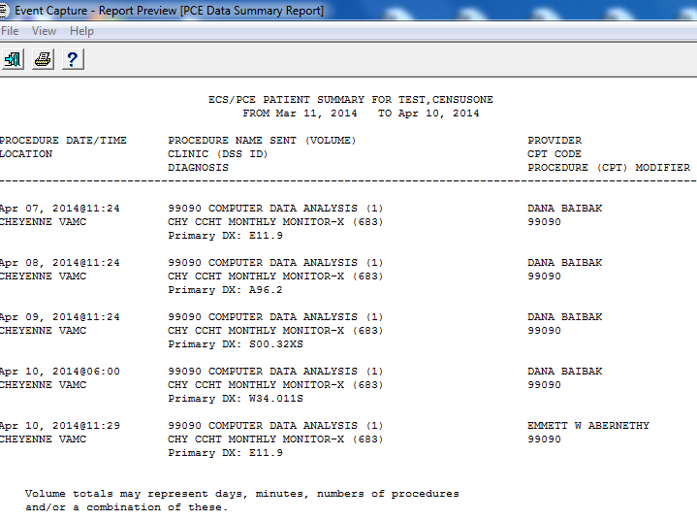

Technical Information

Routines
Some VistA routines the Event Capture GUI uses were modified to replace direct global reads and old Application Program Interfaces (APIs) with new Standards and Terminology Services (STS) APIs and Lexicon APIs wherever possible.
The following APIs are referenced:
- $$SINFO^ICDEX supported by ICR #5747
- $$ICDDX^ICDEX supported by ICR #5747
- $$IMPDATE^LEXU supported by ICR #5679

Online Help for ICD-10 Codes
Help text is included for prompts related to ICD-10 codes. Press F1 or click ? Help Topic to view the online help.

